* [Retail Sales Promotion (Neural Net/C&RT)](http://127.0.0.1:54857/help/topic/com.ibm.spss.modeler.tutorial/clementine/exretailoverview.htm)

# Retail Sales Promotion (Neural Net/C&RT)

This example deals with data that describes retail product lines and the effects of promotion on sales. (This data is fictitious.) Your goal in this example is to predict the effects of future sales promotions. Similar to the condition monitoring example, the data mining process consists of the exploration, data preparation, training, and test phases.

This example uses the streams named goodsplot.str and goodslearn.str, which reference the data files named GOODS1n and GOODS2n. These files are available from the Demos directory of any IBM® SPSS® Modeler installation. This can be accessed from the IBM SPSS Modeler program group on the Windows Start menu. The stream goodsplot.str is in the streams folder, while the goodslearn.str file is in the streams directory.

**Examining the Data**

Each record contains:

* *Class*. Product type.
* *Cost*. Unit price.
* *Promotion*. Index of amount spent on a particular promotion.
* *Before*. Revenue before promotion.
* *After*. Revenue after promotion.

The stream *goodsplot.str* contains a simple stream to display the data in a table. The two revenue fields (*Before* and *After*) are expressed in absolute terms; however, it seems likely that the increase in revenue after the promotion (and presumably as a result of it) would be a more useful figure.

*Figure 1. Effects of promotion on product sales*

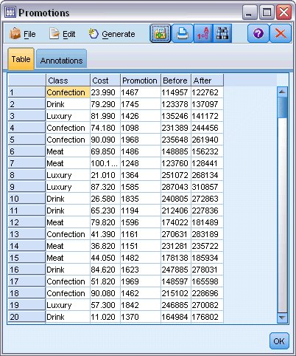

*goodsplot.str* also contains a node to derive this value, expressed as a percentage of the revenue before the promotion, in a field called *Increase* and displays a table showing this field.

*Figure 2. Increase in revenue after promotion*

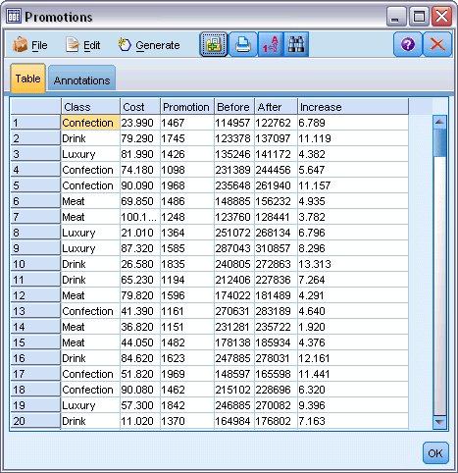

In addition, the stream displays a histogram of the increase and a scatterplot of the increase against the promotion costs expended, overlaid with the category of product involved.

*Figure 3. Histogram of increase in revenue*

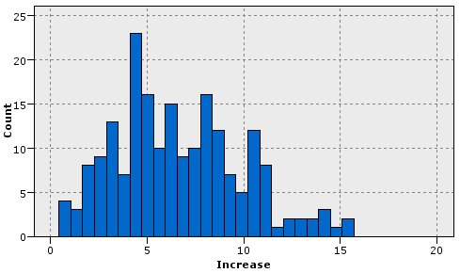

The scatterplot shows that for each class of product, an almost linear relationship exists between the increase in revenue and the cost of promotion. Therefore, it seems likely that a decision tree or neural network could predict, with reasonable accuracy, the increase in revenue from the other available fields.

*Figure 4. Revenue increase versus promotional expenditure*

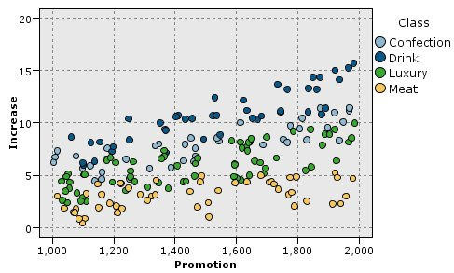

# Learning and Testing

The stream goodslearn.str trains a neural network and a decision tree to make this prediction of revenue increase.

*Figure 1. Modeling stream goodslearn.str*

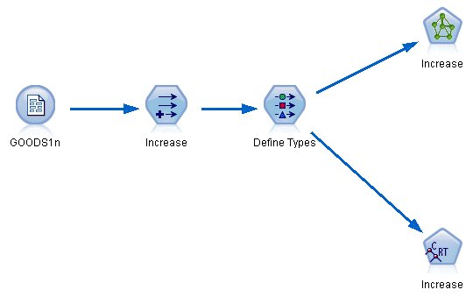

Once you have executed the model nodes and generated the actual models, you can test the results of the learning process. You do this by connecting the decision tree and network in series between the Type node and a new Analysis node, changing the input (data) file to GOODS2n, and executing the Analysis node. From the output of this node, in particular from the linear correlation between the predicted increase and the correct answer, you will find that the trained systems predict the increase in revenue with a high degree of success.

Further exploration could focus on the cases where the trained systems make relatively large errors; these could be identified by plotting the predicted increase in revenue against the actual increase. Outliers on this graph could be selected using the interactive graphics within SPSS® Modeler, and from their properties, it might be possible to tune the data description or learning process to improve accuracy.